**EXPERIMENT 9**

**Aim :**

To prepare Collaboration Diagrams for the Application Software – **Bill Management System.**

**Theory :**

**What is Collaboration Diagram ?**

A Collaboration Diagram also known as Communication Diagram offers the same information as a [Sequence Diagram](https://www.lucidchart.com/pages/uml-sequence-diagram), but while a Sequence Diagram emphasizes the time and order of events, a Collaboration Diagram emphasizes the messages exchanged between objects in an application. Collaboration Diagrams offer the broader perspective within a process.

**Benefits of Collaboration Diagram :**

* Model the logic of a sophisticated procedure, function, or operation.
* Identify how commands are sent and received between objects or components of a process.
* Visualize the consequences of specific interactions between various components in a process.
* Plan and understand the detailed functionality of an existing or future scenario.

**Collaboration Diagram Symbols and Notation :**

* **Rectangles** represent objects that make up the application.
* **Lines** between class instances represent the relationships between different parts of the application.
* **Arrows** represent the messages that are sent between objects.
* **Numbering** lets you know in what order the messages are sent and how many messages are required to finish a process.

Collaboration Diagrams for the Application Software – **Bill Management System :**

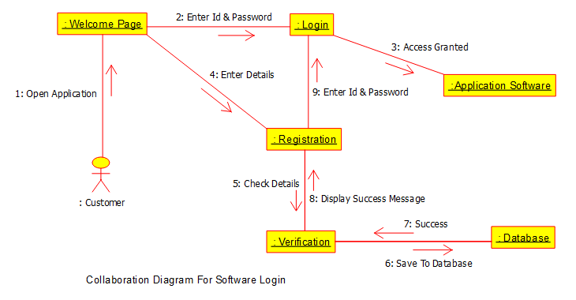

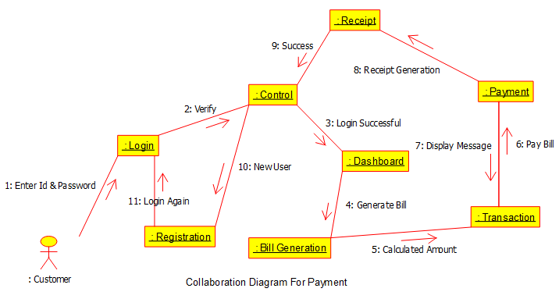

**Conclusion :**

The Collaboration Diagrams for the Application Software – **Bill Management System** were prepared successfully.